ALL INDIA COUNCIL FOR TECHNICAL EDUCATION

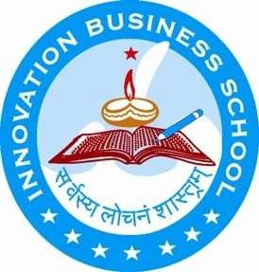

Submitted for
Compliance Report 2021-2022 submitted along with Mandatory
Disclosure

INNOVATION-THE BUSINESS SCHOOL
At.Tarakai,Po.Muktapur,Dist.Khuda,State.Orissa
Phone :06755-224071, Fax:06755-224072, Website:
www.ibschool.org.in,email:contactus@ibschool.org.in

- Name of the Institution: INNOVATION – THE BUSINESS SCHOOL, TARKAI, MUKTAPUR,KHURDHA
TEL: 0674 -2742400 PIN:752055,
Email: contactus@ibschool.org.in MOBILE:9437052325

Name and address of theTrust
INNOVATION TRUST
VIM 154, SAILESHREE VIHAR CHANDRASEKHARPUR, BHUBANESWAR
CHARPERSON: Dipti Tripathy MOBILE.NO.: 9437052352
EMAILID : diptitripathy05@gmail.com
MANAGINGTRUSTEE: SukhjinderSingh MOBILE.NO.: 9437012325
EMAILID : sukhjinder05@gmail.com

Name and Address of thePrincipal

NAME : Dr. Mamata Dey
ADDRESS : Tarakai, Muktapur, Khurda -752055 MobileNo. : 8895730964

Name of the AffiliatingUniversity

AICTE, MINISTRY OF HRD, GOVT OF INDIA

Governance

5.1 | Governing Board Members | - Ms. Dipti Tripathy - Chairperson of IBS, MBA(HRM)  - Dr. Sukhjinder Singh – Managing Trustee of IBS, MBA (HRM),LLB  - Dr. R.K. Paramguru – Director IBS - Rtd. Head, Hydro & Electro Metallurgy Dept., IMMT, M.Tech inMetallurgy  - Mr. Anand Mohan Tripathy – Director,IBS  Rtd. Group General Manager, ONGC  - Dr. Bhagbat Nath – EX.Principal, IBS, Ph.D (English), MA inEnglish,  - Mr. Bijay Kumar Sarangi, Director,IBS, MBA (HRM &Marketing)  - Nominee of the AICTE-Regional Office(Ex- Officio), Eastern Zone  - Nominee of the State Government–  Director of Technical Education (Ex.Officio)  - Mr. Nand Kishore Taori, - Rtd.Managing  - Director – Steel Business, AMTEKAUTO  - LIMITED, New Delhi, Mtech(  Metallurgy)  - Prof.(Dr.) Sudhakar Panda -Ex-Prof. of Economics UtkalUniversity  - Prof.(Dr.) MeeraPanigrahi  Ex. Prof of English, Berhampur University
 | Frequency of Board meetings & date of last meeting | Half yearly

5.2 | Academic Advisory Body | - Ms. Dipti Tripathy- Chairman,IBS  - Dr. Sukhjinder Singh-Managing TrusteeIBS  - Dr. R.K. Paramguru – Director IBS -Rtd. Head, Hydro & Electro Metallurgy Dept., IMMT, M.Tech inMetallurgy  - Mr. Anand Mohan Tripathy – DirectorIBS  Rtd. Group General Manager, ONGC  - Prof. (Dr.) MamataDey– PrincipalIBS  - Dr. P.C. Biswal – Ex. Principal,IBS  - Dr. BhagbatNath– Ex. Principal,IBS  - Prof.(Dr.) Sudhakar Panda -Ex-Prof. of Economics Utkal University  - Porf.(Dr.) Harish Kumar – Professor in Management , GD Central University,Bilashpur
 | Frequency of Academic Advisory Body meeting | Annually

5.3 Organizational chart andprocesses
Vice-Principal
Manager (Finance, Establishment, Admn, Estate etc.
Administrator
Principal

Trust
Governing Body

Chairman/Secretary
Director

Faculty & Supporting Staffs
Assistant Managers

5.4 | Student feedback mechanism on Institutional Governance / Faculty performance | Regular feedback, monitoring system from students regarding faculty performance, Institutional Governance through specified proforma.
5.5 | Grievance redressal mechanism for faculty, staff and students | 3 tier Grievance redressal system is being formed to take care of faculty, staff and students.
5.6 | Nature and Extent of involvement of Faculty and students in academic affairs/improvements | 1)Regular Industry visit, 2)seminar presentation by faculties and students, 3)Seminar talk by Industry Exports and interaction with faculty and students
5.7 | Mechanism/Norms and procedure for democratic/good Governance | Continuous evaluation of procedures and practices
5.8 | Establishment of Anti Ragging Committee | Yes
5.9 | Establishment of Online Grievance Redressal Mechanism | Yes
 | Establishment of Grievance Redressal | Yes, we have proper Grievance Redressal Committee and

5.10 | Committee in the Institution and Appointment of OMBUDSMAN by the University |  |  |  | the OMBUDSMAN appointed by the Intuition
5.11 | Establishment Committee(ICC) | of | Internal | Complaint | Yes
5.12 | Establishment of Committee for SC/ST |  |  |  | Yes
5.13 | Internal Quality Assurance Cell |  |  |  | Yes

Programmes

  - Name of Programmes Approved by AICTE – POST GRADUATE DIPLOMA
IN MANAGEMENT (PGDM)
  - Name of Programmes Accredited by AICTE -NIL
  - Status of Accreditation of the Course -NA

  - For each programme the following details are to be given:

Name : POST GRADUATE DIPLOMA IN MANAGEMENT (PGDM)
    - Number of Seats: 60
    - Duration : 2YEARS

    - Cut off marks/rank of admission during the last three years : LAST QULIFYING EXAM GEN – 50%, SCST –45%

Fee : RS. 350000/- FOR 2YEARS
    - Placements Facilities : 100% ASSISTANCE

    - Campus placement in last three years with minimum salary, maximum salary and average salary :MIM. SALARY RS. 180000/-PA, AVG. SALARY RS. 250000/-PA AND MAX. SALARY RS.350000/-PA

  - Name and duration programme(s) having Twinning and Collaboration with Foreign University(s) and being run in the same campus along with status of their AICTE approval. if there is Foreign Collaboration, give the following details : Not Applicable

Faculty
  - Branch wise list Facultymembers:

    - Permament Faculty :8
    - AdjunctFaculty :NIL
    - Permament Faculty Student Ratio :15:1
  - Number of Faculty employed and left during the last threeyears

Profile ofPrincipal
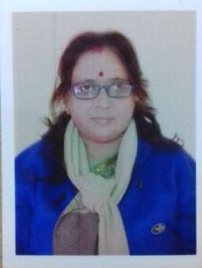
- Work Experience:
  - Teaching: THIRTY SIX YEARS
  - Research: NONE
  - Industry :NONE
  - Others :NA
- Area of Specialization: COMMUNICATIVE ENGLISH
- Course taught of : Post Graduate Level : MBA/PGDM
- Research guidance:
  - No. of paper published in national/International Journals :ISBN AND ISSN NOS.- MORE JOURNALS.
  - Master :NONE
  - Ph.D :TWO
- Projects Carried out: TWO RESEARCH PROJECT
- Patents :NONE
- Technology Transfer :NA
- Research Publications:05
- No of books published with details: TWO NOVELS AND ONE SHORTSTORY
Name: PROF. (Dr.) MAMATA DEY
Date of Birth: 02.08.1958
Unique ID: 1-468 228 960 4
Educational Qualifications:
- Ph.D (ENGLISH) – UTKAL UNIVERSITY(2000)
- M.Phil (ENGLISH) – UTKAL UNIVERSITY(1993)
- MA (ENGLISH) – UTKAL UNIVERSITY(1980)
- BA (ENGLISH) – UTKAL UNIVERSITY(1978)
i.
ii. iii.iv.

- Profile Faculty

- Name:- LaxmidharSahoo

- Designation:- Asst. Prof.(Systems

- Unique ID:- 1-429 480283

- Date of joining the institution:-1.08.2009

- Qualification with class/Grade:-BE Comp Sc& MBA Systems - 1stDIV.

- Total Experience in Years:-1. Teaching- 17
- Industry -Nil
3.Research- Nil
- Area of Specialization: Systems/ Operations Management
- Course taught of Post Graduate: Btech/PGDM
- Research guidance :Nil
- Master :NONE
i. Ph.D: NONE
- Projects Carried out :NONE
- Patents :NONE
- Technology Transfer :NA
- Research Publications :NONE
- No of books published with details :NONE

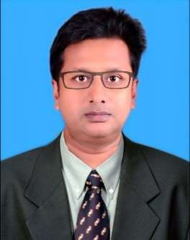

Name: ASST. PROF. SOVAN MANGARAJ
- Date of Birth : 12.01.1979
- Unique ID : 1-207 520 9908
- EducationalQualifications:

MBA (MARKETING)–ICFAI UNIVERSITY(2010)
MA (ECONOMICS) – UTKAL UNIVERSITY(2000)
BA (ECONOMICS) – UTKAL UNIVERSITY (1998)
- WorkExperience:

Teaching : NINEYEARS
Research : NONE
Industry : SIXYEARS
Others : NA
- Area of Specialization : MARKETING / ECONOMICS / STRATEGIC MANAGEMENT
- Course taught of Post Graduate : MBA/PGDM
- Researchguidance: No. of paper published in national/International Journals/Conferences:01
What predicts more the sales-force performance: Motivation or satisfaction in the insurance industry; British Journal of Marketing Studies, Vol. 3, No. 5 (June, 2015).
Master : NONE
Ph.D : NONE
Projects Carried out: NONE
Patents : NONE
Technology Transfer : NA
Research Publications : NONE
No of books published with details : NONE

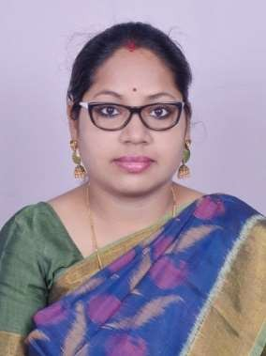

Name: ASST. PROF. MADHUSMITABHUYAN
Date of Birth:01.05.1983
Unique ID: 1-463 590 4162E
EducationalQualifications:
  - MBA (HR & FINANCE) – SAMBALPUR UNIVERSITY
  - LLB – CAPITAL LAWCOLLEGE
  - DIPLOMA IN MODERN OFFICE MANAGEMENT –SAMBALPUR
UNIVERSITY
WorkExperience:
  - Teaching: THREE & HALFYEARS
  - Research:NONE
  - Industry: FOURYEARS
  - Others:NA
Area of Specialization: HUMAN RESOURCEMANAGEMENT
Course taught of Post Graduate:MBA/PGDM
Researchguidance:
  - No. of paper published in national/International Journals/Conferences: 01
  - Master:NONE
  - Ph.D:NONE
Projects Carried out:NONE
Patents:NONE
Technology Transfer:NA
Research Publications:NONE
No of books published with details:NONE

Name: ASST. PROF. DEBABRATMAHANTA
Date of Birth:09.06.1990
Unique ID: 1-467 536 7083E
ducationalQualifications:
  - PGDM (MARKETING & HR) – REGIONAL COLLEGE OFMAMANGENT
  - Bsc (PHYSIC) – NORTH ODISHAUNIVERSITY
WorkExperience:
  - Teaching: THREE AND HALFYEARS
  - Research:NONE
  - Industry: TWOYEARS
  - Others:NA
Area of Specialization: MARKETING/HUMAN RESOURCES MANAGEMENT
Course taught of Post Graduate:MBA/PGDM
Researchguidance:
  - No. of paper published in national/International Journals/Conferences: NONE
  - Master:NONE
  - Ph.D:NONE
Projects Carried out:NONE
Patents:NONE
Technology Transfer:NA
Research Publications:NONE
No of books published with details:NONE

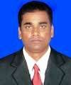
Name: ASST. PROF. SUJEET PRAKASHPATRA
Date of Birth:06.03.1984
Unique ID: 1-463 728 9454
EducationalQualifications:

MBA (FINANCE & MARKETING) – BPUT, ODISHA
  - MCOM (FINANCE) – REVENSHAWUNIVERSITY
  - BCOM – UTKALUNIVERSITY
WorkExperience:

Teaching: NINEYEARS
  - Research:NONE
  - Industry:NONE
  - Others:NA
Area of Specialization: FINANCIAL MANAGEMENT / FINANCIAL ACCOUNTING / PRINCIPLES OF MANAGEMENT / BANKING & INSURANCE MANAGEMENT / STRATEGIC MAMANEMENT / PORTFOLIOMANAGEMENT
Course taught of Post Graduate:MBA/PGDM
Research guidance:
  - No. of paper published in national/International Journals/Conferences: NONE

Master:NONE
  - Ph.D:NONE
Projects Carried out:NONE
Patents:NONE
Technology Transfer:NA
Research Publications:NONE
No of books published with details:NONE

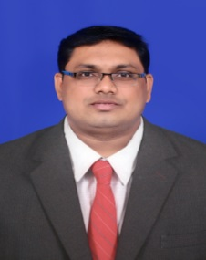
- Name:- Smruti Ranjan Sahoo
- Designation:- Assistant Professor
- Unique ID:- 1-11080603771
- Date of joining the institution:- 23/12/2022
- Qualification with Class/Grade:-MBA(1st Class), M.Com(1st Class)
- Total Experience in Years:- Teaching – 11 years
          - Industry – 1 year
          - Research - 1 year
- Area Of Specialisation: Accounting and Finance
- Course taught of Post Graduate:- Accounting and Finance
- Research Guidance:- NIL
- Master:- MBA,M.COM
- Ph. D:- NIL
- Project Carried Out:- Consumer Behaviour On Reliance Fresh
- Patents:- NIL
- Technology Transfer:- NIL
- Research Publications:- Start Up India, Innovation and Entrepreneurship
- No. Of books published with details:- NIL

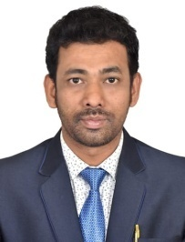
- Name : SATYABRAT DASH

- Date of Birth : 10/07/1988

- Unique ID : 1-360 240 309 5

- Educational Qualifications COST ACCOUNTANT(ICAI)
and M.Com

- Work Experience 10 YEARS

      - Teaching& Research 5 YEARS

      - Industry& Auditing 5 YEARS

- Area of Specialization FINANCE
- Course taught of Post Graduate - PGDM

- Research guidance – NIL

- Projects Carried out In Odisha Livelihood Mission
(FMS version implemented by World bank)
- Patents : NA
- Technology Transfer : NA
- Research Publications : NA
- No of books published with details : NA

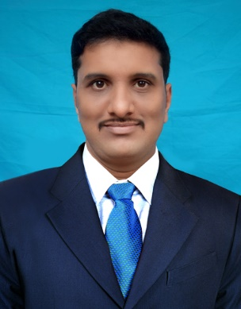
- Name:- Priyabrata Panigrahi
- Designation:- Assistant Professor in Marketing
- Unique ID:- 1-11080603751
- Date of joining the institution:- 20-12-2021
- Qualification with Class/Grade:- MBA Grade A
- Total Experience in Years:- Teaching – 4Years
          - Industry – 2years
          - Research - NIL
- Area Of Specialisation: Marketing Management, Human Resource Management
- Course taught of Post Graduate:- Marketing Management, Sales & Distribution Management, Product & Brand Management, Consumer Behaviour International Business, Managerial Economics,
- Research Guidance:- NIL
- Master:-MBA(Marketing & Human Resource)
- Ph. D:- NIL
- Project Carried Out:- Total Quality Management at Hindustan Aeronautics LTD, Engine Division, Sunabeda,Koraput
- Patents:- NIL
- Technology Transfer:- NIL
- Research Publications:- NIL
- No. Of books published with details:- NIL

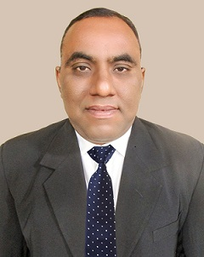
- Name:- Jayesh Yohannan
- Designation:- Assistant Professor
- Unique ID:- 1-11080603732
- Date of joining the institution:- 20th December 2021
- Qualification with Class/Grade:- MBA, 1st Class
- Total Experience in Years:- Teaching – 2 Months
          - Industry – 15 Yrs
          - Research - Nil
- Area Of Specialisation: Strategic HR, HR Analytics, Human Resource Development, HR Operations, Compliance & Labour Laws, Industrial Relations & Employee Relations, Compensation & Benefits, Talent Acquisition, HRP, HR Audits, Corporate Ethics, Business Communications & Etiquette.
- Course taught of Post Graduate:- HRD, IR & Labour Laws, Business Communications
- Research Guidance:- Nil
- Master:- MBA- HR
- Ph. D:- Perusing
- Project Carried Out:- Nil
- Patents:- Nil
- Technology Transfer:- Nil
- Research Publications:- Nil
- No. Of books published with details:- Nil

Fee

FEE STRUCTURE

Particulars | 1st Year Installment Amount (Rs.) | 2nd Year Installment Amount (Rs.)
Registration Fee (to be paid at the time of Admission) | 30,000.00 | 0.00
Tuition Fee | 1, 35,000.00 | 1, 35,000.00
Library & Computer Lab Charges | 10,000.00 | 10,000.00
Examination Fee @ Rs. 5000/- per Trimester | 15,000.00 | 15,000.00
Caution Deposit (Refundable) | 10,000.00
TOTAL: | 2,00,000.00 | 1,60,000.00
GRAND TOTAL: | Rs. 3,60,000.00
HOSTEL FEE: | Rs. 50000/- per year to be paid at the beginning of the session.

Registration fee to be paid at the time of Admission | Rs.30,000/-
1stinstallment with Caution Deposit to be paid before the session start in 1st year | Rs. 1,70,000/-
2ndinstallment to be paid at the beginning of the 2ndyear | Rs. 1,60,000/-

Admission

 | 2018-2019 |  |  | 2019-2020 |  |  | 2020-2021
NO. OF APPROVED SEAT | 60 |  |  | 60 |  |  | 60
 | GEN | OBC | SCST | GEN | OBC | SCST | GEN | OBC | SCST
NO. OF STUDENTS  ADMITTED | 08 | 02 | 50 | 12 | 19 | 29 | 08 | 03 | 22
NO. OF APPLICATION RECEIVED UNDER  MANAGEMENTQUOTA | 00 | 00 | 00 | 00 | 00 | 00 | 00 | 00 | 00

- Admission Procedure
Admission tests | MAT OJEE  ATMA | www.aima.in  www.ojee.nic.inwww.atmaaims.com

  - Number of seats allotted to different Test Qualified candidate separately:

25% seat from OJEE, 25% seat from MAT & 50% seat from ATMA

- Criteria and Weightages forAdmission

- EntranceExamination : 35%
- GroupDiscussion : 20%
- PersonalInterview : 20%
- PastAcademicRecord : 15%
- Weightage forparticipation in : 10% Sports, Extra-curricular Activities, Academic Diversity,Gender
Diversity & Job Experience

- Results of Admission Under Management Seats/Vacant seats : No Management seat in PGDM

Information of Infrastructure and Other Resources Available

Infrastructures | Quantity | Size | Capacity
Class Room | 2 | 151.8 sqm each | 60 each
Tutorial Rom | 1 | 36 sqm | 60
Computer Laboratory | 1 | 77 sqm | 60
Computer Centres | 1 | 150 sqm | 60

Infrastructures | YES /  NO
Barrier Free Building | YES
Occupancy Certificate | YES
Fire & Safety Certificate | YES
Hostel Facilities | YES

  - Library

Library Facilities | YES /  NO | Quantity
Library Books | YES | 6000
Journals availability | YES | 36
Online National Journals | YES | 20
Online International Journals | YES | 25
E - Library Facilities | YES | 3500

  - ComputingFacilities
Computer Facilities | YES /  NO | Quantity
Internet Bandhwidth | YES | 512  mbps
System | YES | 60
System connected to WAN | YES | 30
System connected to LAN | YES | 60
Software Packages | YES | 10

Innovation Cell | YES
Social Media Cell | YES
Games & Sports | YES
Compliance of the National  Academic Depositary (NAD), | YES

  - List of Facilitiesavailable

Games & Sports | YES
Extra - Curricular Activities | YES
Soft Skill Development | YES

  - Teaching LearningProcess
Teaching Learning Process
Curricula & Syllabus | AVAILABLE IN THE WEB SITE
Academic Calendar | 1ST JUNE TO 31ST MAY
Teaching Load of Faculty | 3 CLASSES PER WEEK
Internal Continuous Evaluation | MID AND END TERM EXAM  PER TRIMESTER
Student Assesment of Faculty | STUDENT FEEDBACK
Title of Course | PGDM

Enrollment of Students in the last 3 years – UPLOADED ONTO WEBSITE

- List of Research Projects/Consultancy Works :NONE

Number of Projects | NONE
Publications | NONE
Industry Linkage | YES
MOU with Industries | YES

18. NBA Accreditation Status
1 | Name/ List of Program / Courses Accredited | NOT ACCREDITED
2 | Applied for Accreditation | NOT APPLIED
 | A. Applied but Visit not happened
 | B. Visit happened but result awaited
3 | List of program / courses Not Applied | POST GRADUATE DIPLOMA IN MANAGEMENT (PGDM)
19. NAAC Accreditation Status
1 | Accredited | NOT ACCREDITED
2 | Applied for Accreditation | NOT APPLIED
 | A. Applied but Visit not happened
 | B. Visit happened but result awaited
3 | Not Applied | NOT APPLIED

